Santiago Paz  
November 7, 2014

Analyst Report

Professor Von Deak

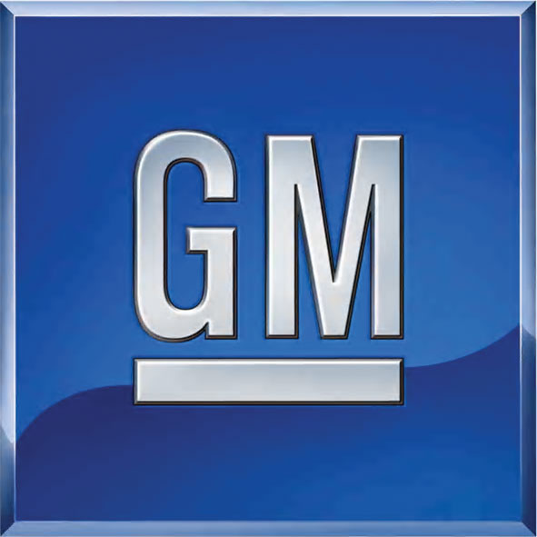

I have read and understand the academic honesty policy as outlined in the syllabus and the student handbook.  By affixing this statement to the title page of my paper, I certify that I have not cheated or plagiarized in the process of completing this assignment.  If it is found that cheating and/or plagiarism did take place in the writing of this paper, I understand the possible consequences of the act/s, which could include, but are not limited to a ZERO for this assignment and a failing grade for the course.

**Table of Contents**

Part 1 3

Part 2 4

Part 3 4 - 8

Part 4 8 - 16

Part 5 16 - 19

Works Cited 20 - 21

**Part 1***Executive Summary*

Ever since GM was founded on September 16, 1908, it has prospered through historical events such as 2009, and has become one of the world leading companies in the automotive industry. It currently operates in the durables sector. GM operates in North America under the brands Buick, Cadillac, Chevrolet, and GMC. At a quick glance, GM’s Current Ratio is 1.31, Debt to Equity Ratio is .92, and its quick ratio is .83. According to this financial information the company is healthy. Recently, the company acquired a new CEO, Mary Barra. Unfortunely, she was named CEO during a time of despair for GM. For almost a year now the company has been recalling vehicles due to faulty ignition switches. This is costly and bad PR for the company, but ambitious Barra intends to bring GM to a level of prestige among the other automotive companies. These companies are doing fairly well relative to GM, especially the new automobile manufacturer, Tesla. It has been producing what current consumers want out of their vehicle has technology integrated in it as well as a vehicle that is more greener. The future looks bright for the automotive industry that has recently been struggling with its faulty ignition switches. Since the price of gasoline has recently been dropping more, consumers are going to be willing to spend money on some of GM’s most popular trucks that generate a large portion of its revenue. If you’re wondering whether or not to invest in GM, please continue reading to look at the company more in depth.

**Part 2**

*Company Profile*

* Ticker symbol: GM
* G.M. is a multinational corporation engaged in socially responsible operations, worldwide. It is dedicated to provide products and services of such quality that our customers will receive superior value while our employees and business partners will share in our success and our stock-holders will receive a sustained superior return on their investment
* HQ Location: Detroit
* Date of Incorporation: September 16, 1908
* Public Auditor: Deloitte & Touche LLP
* CEO: Mary T. Barra
* CFO: Chuck Stevens
* Stock Type: Common
* Exchange: New York Stock Exchange (NYSE)
* Dividends: March 14, June 6, Sept 8, $.3 for each

**Part 3**  
*Industry Profile*

*Market Sector*

Stocks can be classified into market sectors. These are businesses in which the good or services produced are very similar to each other. For example, GM is classified into the consumer durables. It competes with the top three which are Tesla Motors, Dixie Group, and Fuel Systems Solutions. At the bottom of the sector there is Universal Mfg. Co, Aero Grow International, and Grapheme 3d Lab.

*Industry*

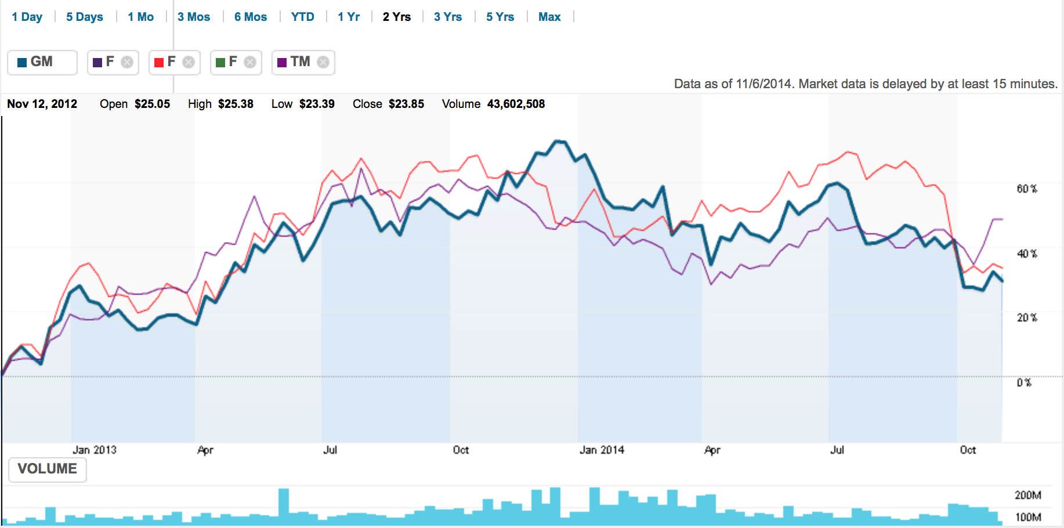There are categories within a sector, which are called industries. Industries tend to be more specific. General Motors belong to the Automotive Industry. Companies involved in the automotive industry manufacture mostly vehicles, but they are also involved in the design and development aspect of the automobiles.

*Company Events*

On December 10, 2013 General Motors named Marry Barra as the new CEO of GM. She replaced Dan Akerson on January 15, 2014. Since August (2013), Barra has served as executive vice president of global product development and global purchasing and supply chain, according to her company bio.[1] This event is important because the stock price to slightly rose then fell. On March 18, 2014, news was released that GM recalled an additional 1.5 million vehicles. This caused the stock price to go down. The article states “General Motors ([GM](http://money.cnn.com/quote/quote.html?symb=GM&source=story_quote_link)) has been getting a lot of attention and criticism for its recall of 1.6 million vehicles worldwide to deal with an ignition switch problem. GM engineers knew at least [as early as 2004](http://money.cnn.com/2014/02/28/autos/gm-recall-timeline/index.html?iid=EL) of the problem, but the company did not recall the vehicles until [February of this year](http://money.cnn.com/2014/02/13/autos/gm-recall/index.html?iid=EL)” (Isidore 1). GM was able to turn this stock drop around however, after it agreed to pay a $35 million fine to the National Highway Traffic Safety Administration. On May 05, 2014, we can see a noticeable increase of the company’s stock price. According an article, “GM shares were trading higher late Friday morning, up 3 cents to $34.39, possibly reflecting the relatively small scale of the fine” (Reed 1). Unfortunately all good things must come to an end. Families who were victims of the faulty vehicles, denied the compensation of $1 million dollars offered to them by GM. They don’t want the money; they want to see GM in court. It became known the public that GM was in fact aware of these faulty ignition switches that were responsible for these tragic accidents. Due to this dilemma, it’s obvious to see why the stock price falls on June 30, 2014. Since then, the GM stock has continued to decline.

*Market Capitalization*

Market capitalization is the total dollar market value of all of a company's outstanding shares.[2] Toyota motors most likely has the highest market cap because its vehicles are reliable and cheap. General Motors and Ford Motor are very close, but Ford is able to be yet the bigger company since its vehicles do not have faulty ignition switches. Since Tesla is still relatively new, it’s only natural to have a small market cap.

*Global Presence*

The president of Brazil, Dilma Rouseeff, wants its country to produce more goods domestically. One of her methods is to increase an excise tax on foreign vehicles as much as 30% of their value. This could well in fact hurt the automotive industry, since they will reduce the number of imported vehicles into Brazil with such taxes. However, GM also has a presence in Juarez, Mexico; a city with a high crime rate and a total of 359 murders in September 2010 is making a recovery into a location for companies seeking to do business. On October 21, 2014 people filled the city’s car dealerships that include Chrysler, Ford, Toyota, and GM. This is very positive not only for GM, but for the automotive industry as a whole since Juarez is transforming into a more appealing location for business. On the other side of the world the Chinese are not pleased with what they are receiving from General Motors. General Motors is the parent company of popular American car companies such as Buick, Cadillac, and Chevrolet. A survey in China found the Cadillac to be below average. Buick and Chevrolet however did not make the list.

**Part 4**

*Current Events/Future Outlook*

*Domestic*

The article U.S. companies return to Mexico’s one-tie ‘murder capital’ discusses how one of the most dangerous cities in Mexico, is making its way back into investors eyes. The city of Juarez in Mexico has been a place where no one would think of ever visiting. Its murder rate is above average with the month of September having 359 murders alone. Seeing these numbers in 2012, investors would never think this would be a place to make money. However, Juarez has been relentlessly trying to drop the city’s crime in order to give people a sense of security. Delphi, a leader in the manufacturing of automotive parts, invested $71 million in the past two years. U.S. companies have even noticed the improvements Juarez has undergone, and did in fact feel the effect. On October 17, 2014 people filled the city to spend money on automobiles companies such as Chrysler, GM, Ford, and Toyota. The city’s food places also felt the full effect of these shoppers. Juarez still has a lot of room for improvement, but until then these companies in the automotive industry will see good results from Juarez. I think it’s important that this article is included in my report, because it doesn’t just talk about GM, it talks about other companies in the automotive industry. This information gives us a much larger perspective on the numbers we see on the financial statements.

**

**

**

*Global*

*EU steps up trade fight with Brazil over local content rules* is an article regarding the European Union (EU) disputing with Brazils recent policies regarding trade. After Dilma Rousseff won her second term, the regulations that were to be implanted appeared. The EU claimed “The Brazilian tax measures give an unfair advantage to domestic producers and go against WTO rules”. The Brazilian government is trying its best to allow these new regulations to go through. One of the biggest changes includes an increased excise tax on cars by up to 30% of their value, which could well in fact hurt the automotive industry. It won’t be just the 30%, because along with other charges, it could accumulate to 80% in some cases. This won’t be appealing to companies in the automotive industry doing business globally. In fact, if it does pass, it could hurt the well being of the companies such as GM that are selling in Brazil.





*Future Outlook*

For GM and its industry the future outlook is looking very positive. Aside from the various recalls, the economy is working in favor with the automotive industry due to falling fuel prices. Simple economics shows that this increases a demand in vehicles. On top of that banks are offering more car loans with lower interest rates.[3] However, a new trend that has appeared in the automotive industry that is electric cars. Reports have said that carmakers have not been up to par with their innovation, as they should. “There are two recent evolutions that have happened – the electric car and the connected car– and the auto industry has shown itself to be very conservative.” The industry seems to be in good shape for the near future, but eventually consumers may want a greener car; only time will tell.

**Part 5**

*Recommendation*

The big question is whether or not to invest in shares of General Motors. There are several different aspects of the company that could give us suggestions on whether or not to invest. Ratios, in particular, give us a deep insight into the company. All ratios are important in determining the health of a company. However, some ratios that give you a quick look at how the company is doing include the Current, Quick, and Debt to Equity ratio. If we take a look at the current ratio we can see how a firm’s current assets compares with its current liabilities. It’s important to note whether or not a company will be able to convert its current assets into cash in case of an emergency. It represents a firm’s financial security in the short term, which is defined as a year or less. Another ratio that is crucial to any firm’s success is how quickly the inventory can be converted into quick cash. The measure of how quickly an asset can be converted into cash is referred to as liquidity. This is measured through the Acid test or quick ratio. If ever need be, a firm needs to be able to determine if they’ll be able to pay short-term debts if they can’t sell inventory. If a company has a high quick ratio, it means they have a safe liquidity position. Another ratio that helps review a firm’s financial condition is the debt to owner’s equity, or leverage ratio. This measures how heavily a firm is depending on borrowed funds for its operations. A company with a high degree of debt relative to its stockholders equity indicates that investing in such a company is risky. If we take a look at the current ratio of GM compared with its top competitors we see that it’s underperforming ford, but still ahead of Toyota. By looking at GM’s current ratio of 1.31, it’s safe to say that investing in this company does not present a high level of risk compared to its competitor, Ford. Next we can look at the quick ratio graph. Ford in this case is a very high ratio compared to GM. A quick ratio of .83 means that GM may have trouble paying of its short-term debts. If a company isn’t able to pay off such debts, it is not appealing to investors. By looking at the debt to equity ratio were able to have more of a broader perspective of the company. A higher ratio in this case is not what it meant for the previous two ratios. This actually, is not good. Ford has a leverage ratio of 4.35, which is extremely high, but it’s reasonable if they are financing for large future projects. GM and Toyota are safe since their leverage ratio ranges between .92 and 1.13. GM isn’t the only company with recalls; Ford Motor Company recently announced that it would be recalling over 200k vehicles in North America. The mass population could view this as an automotive industry rather than a single company that is having issues. “General Motors Company posted just a .2 percent gain for month to 22,819 vehicles” (Seward 1). This is positive news for GM since it was still able to see a gain regardless of its recalls. So overall, would I buy shares of the GM stock? Yes, I would buy shares. The reasons are clear from the information provided. Even though BP suffered an oil spill, it was able to bounce back its share price, and who’s to say GM can’t do the same. This company has been around here for so long, that it’s part of our history.

Works Cited

Blanco, Octavio. "U.S. Companies Return to Mexico's One-time 'murder Capital'" *CNNMoney*. Cable News Network, 21 Oct. 2014. Web. 06 Nov. 2014.

"F." *CNNMoney*. Cable News Network, n.d. Web. 06 Nov. 2014.

"HMC." *CNNMoney*. Cable News Network, n.d. Web. 06 Nov. 2014.

Kenwell, Bret. "3 Reasons Investors Should Consider Buying Delphi Stock." *3 Reasons Investors Should Consider Buying Delphi Stock*. N.p., 29 Oct. 2014. Web. 06 Nov. 2014.

Leahy, Joe. "EU Steps up Trade Fight with Brazil over Local Content Rules - FT.com." *Financial Times*. N.p., 31 Oct. 2014. Web. 06 Nov. 2014.

"Market Capitalization Definition | Investopedia." *Investopedia*. N.p., n.d. Web. 03 Nov. 2014.

Murphy, Colum. "In China, Foreign Car Makers Find It Tough to Keep Buyers Happy." *China Real Time Report RSS*. The Wall Street Journal, 03 Nov. 2014. Web. 06 Nov. 2014.

"Sector Definition | Investopedia." *Investopedia*. N.p., n.d. Web. 05 Nov. 2014.

Sparks, Daniel. "Why Tesla Motors Inc. Stock (TSLA) Rebounded Today." *(TSLA)*. N.p., 28 Oct. 2014. Web. 06 Nov. 2014.

"Stock Sectors: Consumer Durables." *CNNMoney*. Cable News Network, n.d. Web. 06 Nov. 2014.

"TSLA." *CNNMoney*. Cable News Network, n.d. Web. 06 Nov. 2014.

Williams, Sean. "Why General Motors Company Is One of the Biggest Warren Buffett Stocks." *(GM)*. The Motley Fool, 26 Oct. 2014. Web. 06 Nov. 2014.

Zacks Equity Research. "Auto Stock Roundup: GM, Ford Beat Earnings, Honda Misses." *- October 30, 2014*. N.p., 30 Oct. 2014. Web. 05 Nov. 2014.

Zacks Equity Research. "U.S. Auto Sales Up on Consumer Confidence, Low Fuel Prices." *Zacks*. N.p., 04 Nov. 2014. Web. 04 Nov. 2014.

1. Bryant, Charles W. "Things You Shouldn't Share on Social Networks." *HowStuffWorks*. N.p., n.d. Web. 05 Nov. 2014.
2. "Market Capitalization Definition | Investopedia." *Investopedia*. N.p., n.d. Web. 02 Nov. 2014.
3. Zacks Equity Research. "U.S. Auto Sales Up on Consumer Confidence, Low Fuel Prices." *- November 4, 2014*. N.p., 04 Nov. 2014. Web. 04 Nov. 2014.